**Christopher King**

**2018141521058**

**Mechanical Design 2**

**Class Section 01**

**10/28/2021**

Use Manufacturer 1 for tapered roller bearings and Manufacturer 2 for all other bearings.

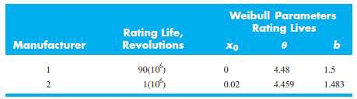

# **Problem 1**

An 02-series single-row ball bearing is to be selected from Table 11–2 for the application conditions of

* Axial load = 3 kN
* Radial load = 8 kN
* Service Life = 108 revolutions
* Outer ring rotation
* Desired reliability = 90%

What size of bearing to use if choosing a deep-groove bearing versus choosing an angular-contact bearing? Discuss the considerations and decide your choice of bearing type for this application.

**Solution:**

Guess and , .

For deep-groove bearing, from Table 11-2, we try deep-groove bearing with , .

In Table 11-1, is correspond to . Therefore, our guess is correct.

Therefore, deep-groove bearing is suitable.

For angular-contact bearing, from Table 11-2, we try angular-contact bearing with , .

In Table 11-1, is correspond to . Therefore, our guess is correct.

Therefore, angular-contact bearing is suitable.

From the analysis above, I can know that the diameter of angular-contact bearing needed to support the same load is smaller than that of deep-groove bearing. In daily use, we will consider the utilization of space, so we are more inclined to choose to use angular-contact bearing.

# **.Problem 2**

A countershaft is supported by two tapered roller bearings using a direct mounting. The radial bearing loads are 560 lbf for the left-hand bearing and 1095 lbf for the right-hand bearing. An axial load of 200 lbf is pushed against the left bearing. The shaft rotates at 400 rev/min and is to have a desired life of 40 kh. Use an application factor of 1.4 and a combined reliability goal of 0.90. Using an initial K = 1.5, find the required radial rating for each bearing.

Select the bearings from Fig. 11–15.

**Solution:**

Therefore, .

Select cone 32305, cup 32305, with 0.9843 in bore, and rated at with .

still exists.

Then,

Select cone M84249, cup M84210, with 1.0000 in bore, and rated at with .

still exists.

# **Problem 3**

Statics analysis indicates the gear contact forces at point E are Fx = -92.8 lbf, Fy = -362.8 lbf, and Fz = +808 lbf. Tapered roller bearings are planned to be used at C and D. Should the bearings be oriented with direct mounting or indirect mounting for the axial thrust to be carried by the bearing at C?

Assuming bearings are available with K = 1.5 and an application factor of one. A bearing life of 108 revolutions is desired with a 90 percent combined reliability for the bearing set.

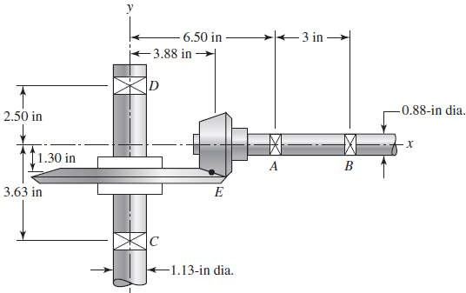

**Solution:**

Gear Load:

– tangential force of ,

– radial force of , and

– thrust force of

The reactions in the plane are

The reactions in the plane are

The radial loads and are the vector additions of and , and and ,

respectively:

Direct Mounting:

Therefore, the axial thrust to be carried by the bearing at C.

Indirect Mounting:

Therefore, the axial thrust to be carried by the bearing at D.

Will select direct mounting since it results in that the axial thrust to be carried by the bearing at C.